**A**

**PROPOSAL**

**ON**

**SMART DUSTBIN**

**TEAM NAME:**

**AEON**

**TEAM MEMEBERS:**

**PREETI ADHIKARI**

**ROHAN BASNET**

**SABAL GAUTAM**

**SAMIR POKHREL**

## ABSTRACT

The growing challenge of waste mismanagement has adverse effects on the environment, primarily due to improper segregation of decomposable and non-decomposable waste. Manual sorting methods are inefficient, time-consuming, and prone to errors, necessitating automated solutions for better waste classification.

This project presents an automated waste image detection system that uses machine learning to identify and classify waste as either decomposable (organic materials like food and plants) or non-decomposable (materials like plastics and metals). The goal is to improve segregation accuracy and enhance the efficiency of waste management systems.

A machine learning model was developed and trained on a comprehensive dataset of waste images. The model employs image recognition techniques to classify waste into the specified categories, achieving robust and real-time detection capabilities.

The system was tested on a diverse set of real-world waste images and demonstrated an accuracy of 90% in distinguishing between decomposable and non-decomposable waste. The implementation of this system can significantly reduce sorting errors, minimize contamination of recyclable materials, and streamline waste processing.

This project highlights the effectiveness of machine learning in automating waste classification based on image data. By enabling accurate segregation of decomposable and non-decomposable waste, the system promotes sustainable waste management practices. Future work will focus on refining the model by expanding the dataset and enhancing its capability to handle mixed or ambiguous waste scenarios.

## CHAPTER 1

## INTRODUCTION

## 1.1 Background

Kathmandu, the capital city of Nepal, has consistently been on the list of most polluted cities in the world. Kathmandu generates around 1,000 tons of waste daily, and majority of the waste is contributed by household waste. Although a significant portion of the waste can be recycled or composted, the lack of infrastructure in waste segregation poses as a hurdle. The challenges in properly segregating waste materials stem from rapid urbanization, historical reliance on informal disposal methods, and limited public awareness about its importance.

### 1.2 Statement of the Problem

### 

Improper sorting of waste materials is one of the most critical issues in the waste management in developing countries. Not properly sorting the waste materials into different categories like biodegradable, recyclable, non-recyclable and hazardous waste and mixing them all together creates several challenges. The problems include health and environmental risks along with increased burden on landfills. Without a proactive approach, mixed waste makes effective waste management increasingly difficulty.

### 

### 1.3 Project objective

Our project aims to promote efficient and automated waste segregation at source, which minimizes the challenges faced during manual sorting. The system aims to distinguish the waste into biodegradable, recyclable and non-recyclable. By doing this, we aim to raise awareness and encourage responsible waste disposal behaviors. This project aspires to mitigate environmental impacts and contribute to a more sustainable urban ecosystem.

**CHAPTER 2**

## SYSTEM DESIGN AND ARCHITECTURE

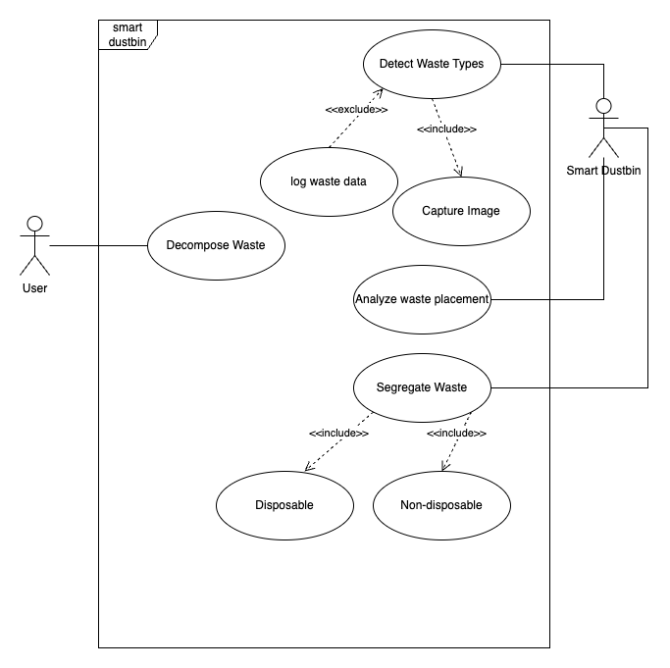

Fig: Use case Diagram

## CHAPTER 3

## EXPECTED OUTPUT

This system will distinguish between the types of waste materials.

## CHAPTER 4

## CONCLUSION

In conclusion, this system addresses critical problems in waste management, particularly the problems in waste segregation. By implementing the system, it not only streamlines waste disposal processes but also reduces environmental hazards and promotes sustainable practices.